Woodside Community Hub User Guide

**Table of Contents**

**Introduction** 2

Description 2

System Requirements 2

**Navigation** 3

Menu Bar 3

Main Menu Form 4

Crèche Menu Form 5

**Adding** 6

Bookings 6

Parents 18

Children 22

**Editing and Deleting** 24

Bookings 24

Parents 28

Children 32

**Assigning Staff** 36

**Viewing Data** 40

**Viewing Report** 42

## **Introduction**

### Description

The Woodside Community Hub system facilitates for easy management of data which was previously managed with paperwork. The user is provided with a smooth and simple experience, allowing them to work efficiently and without any barriers. Due to time constraints, only the crèche subsystem has been implemented. This document aims to give the user all the information needed to take advantage of every aspect of the application, including adding, editing and deleting bookings, parents and children, assigning staff members to shifts, viewing data from the database and viewing a report. These are all important tasks in the day to day running of the crèche.

### System Requirements

*Hardware*

Recommended:

* 2GHz processor
* 4GB RAM
* 500MB storage space
* DirectX 9 graphics with WDDM 1.0 driver

Minimum:

* 1GHz processor
* 3GB RAM
* 250MB storage space
* DirectX 9 graphics with WDDM 1.0 driver

*Software*

Recommended:

* Windows 10
* Visual Studio Express 2015

Minimum:

* Windows Vista
* Visual Studio Express 2013

## **Navigation**

### Menu Bar

The menu bar is accessible to the user at all times, providing instant access to every aspect of the system. It is located at the top of every form.



Functionality:

* ‘Close’ closes the program
* ‘Crèche’ allows user to navigate to any aspect of the crèche subsystem
* ‘Transport’ allows user to navigate to any aspect of the transport subsystem (not implemented due to time constraints)
* ‘After School Club’ allows user to navigate to any aspect of the after school club subsystem (not implemented due to time constraints)
* ‘Advice’ allows user to navigate to any aspect of the advice subsystem (not implemented due to time constraints)
* ‘Groups’ allows user to navigate to any aspect of the groups subsystem (not implemented due to time constraints)
* ‘Classes’ allows user to navigate to any aspect of the classes subsystem (not implemented due to time constraints)

### Main Menu Form

This is what the user will be greeted with when they run the program. From here the user can navigate to the menu screen of each of the six facilities in the Woodside Community Hub system.

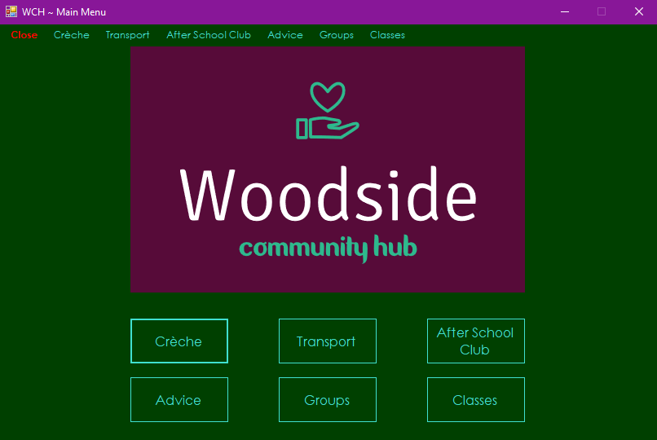

Functionality:

* ‘Crèche’ button navigates user to Crèche Menu Form
* ‘Transport’ button navigates user to transport menu screen (not implemented due to time constraints)
* ‘After School Club’ button navigates user to after school club menu screen (not implemented due to time constraints)
* ‘Advice’ button navigates user to advice menu screen (not implemented due to time constraints)
* ‘Groups’ button navigates user to groups menu screen (not implemented due to time constraints)
* ‘Classes’ button navigates user to classes menu screen (not implemented due to time constraints)

### Crèche Menu Form

This is where the user can access all areas of the crèche facility.

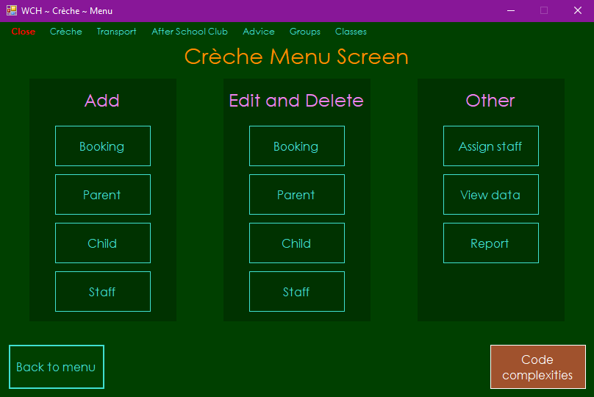

Functionality:

* ‘Booking’ button in ‘Add’ section allows user to add a booking
* ‘Parent’ button in ‘Add’ section allows user to add parents
* ‘Child’ button in ‘Add’ section allows user to add children
* ‘Staff’ button in ‘Add’ section allows user to add staff members (not implemented as same skills were shown elsewhere)
* ‘Booking’ button in ‘Edit and Delete’ section allows user to edit and delete bookings
* ‘Parent’ button in ‘Edit and Delete’ section allows user to edit and delete parents
* ‘Child’ button in ‘Edit and Delete’ section allows user to edit and delete children
* ‘Staff’ button in ‘Edit and Delete’ section allows user to edit and delete staff members (not implemented as same skills were shown elsewhere)
* ‘Assign staff’ button in ‘Other’ section allows user to assign staff members to groups on specific days
* ‘View data’ button in ‘Other’ section allows user to view all data, such as parents, children, bookings, staff members, etc.
* ‘Report’ button in ‘Other’ section allows user to view a report on how many bookings have been made and what the average duration of each booking is
* ‘Back to menu’ button returns user to main menu screen

## **Adding**

### Bookings

1. Click ‘Booking’ button in ‘Add’ section on Crèche Menu Form

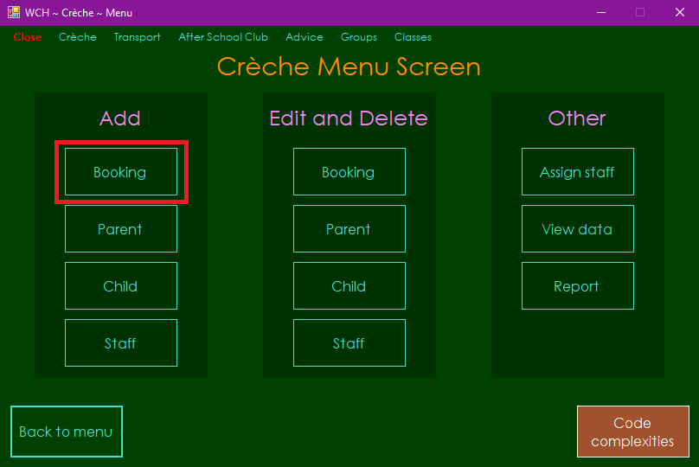

2a (1). *Follow if you wish to select an already existing parent* – Click on the parent you wish to select in the box of existing parents (you can also search for a parent by typing their name into the text box)

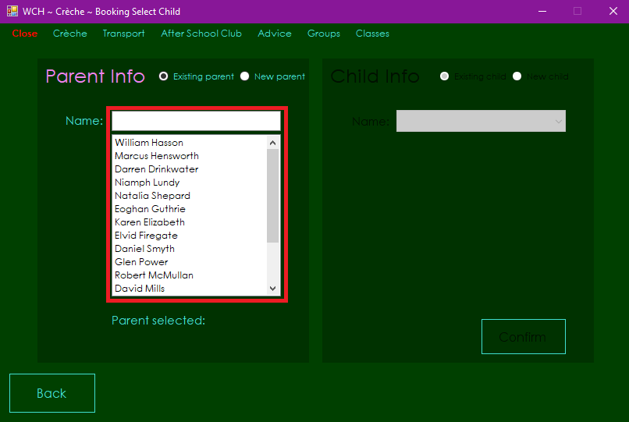

2a (2). *Follow if you wish to select an already existing parent and an already existing child* – Click on the combo box in the ‘Child Info’ section, click on the child you wish to select then click ‘Confirm’ button

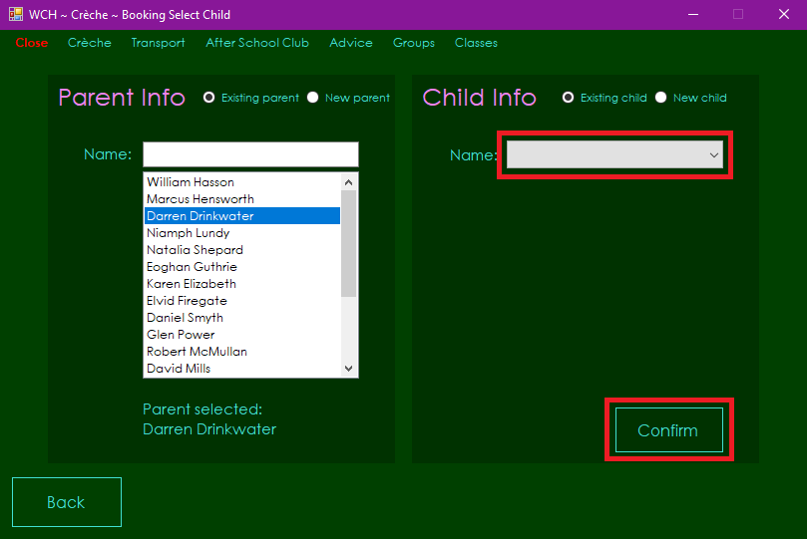

2aa (1). *Follow if you wish to select an already existing parent and add and select a new child* – Click on ‘New child’ radio button

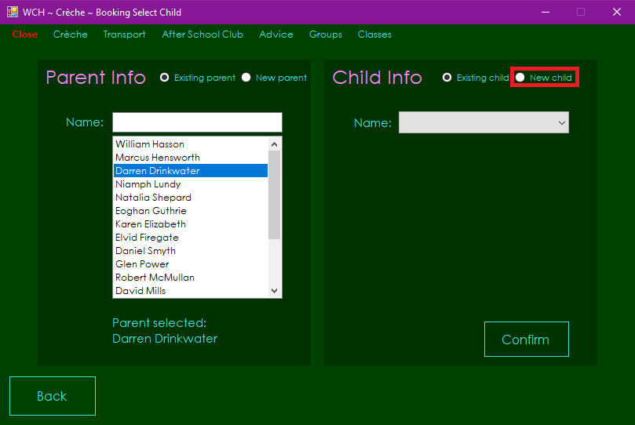

2aa (2). *Follow if you wish to select an already existing parent and add and select a new child* – Input child’s forename and surname into text boxes, select child’s date of birth on the calendar, click ‘Confirm’ button then click ‘Ok’ on message box that appears

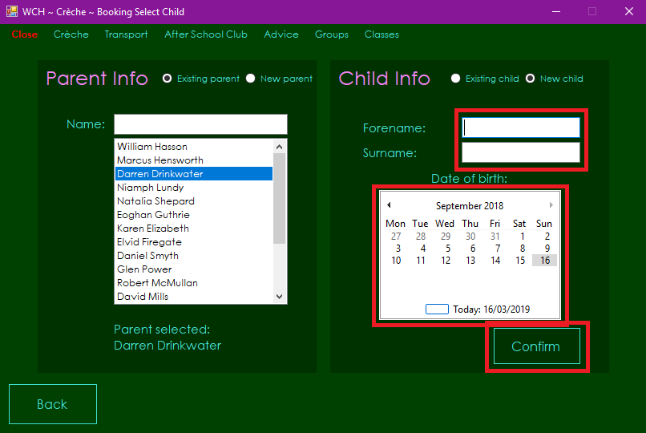

2b (1). *Follow if you wish to create and select a new parent and child* – Click on ‘New parent’ radio button

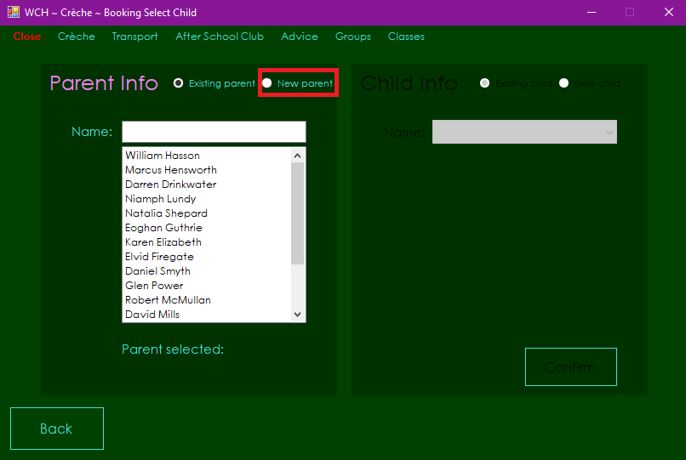

2b (2). *Follow if you wish to create and select a new parent and child* – Fill parent details into text boxes, click ‘Confirm’ button then click ‘Ok’ on message box that appears

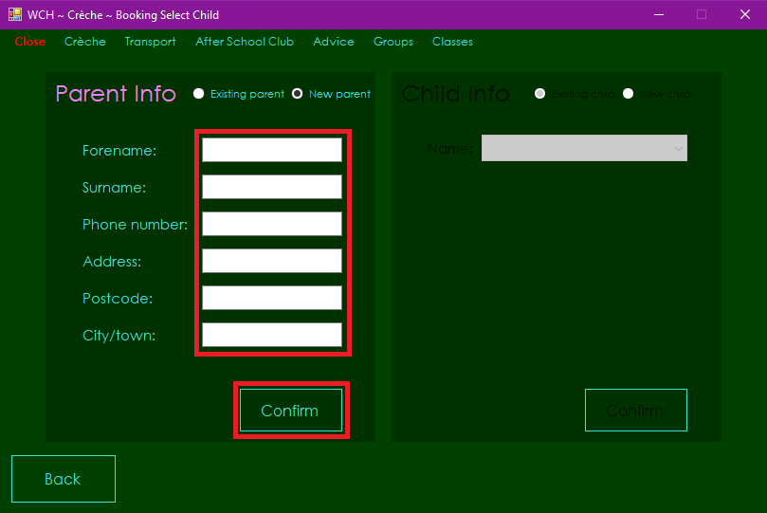

2b (3). *Follow if you wish to create and select a new parent and child* – Input child’s forename and surname into text boxes, select child’s date of birth on the calendar, click ‘Confirm’ button then click ‘Ok’ on message box that appears

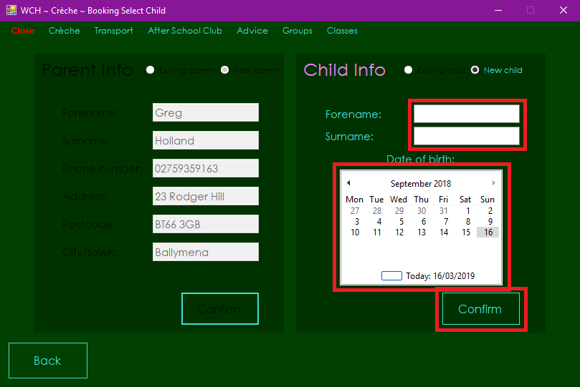

3. Select a start date, end date and the days you wish to book, click ‘Checkout’ button then click ‘Yes’ on message box that appears

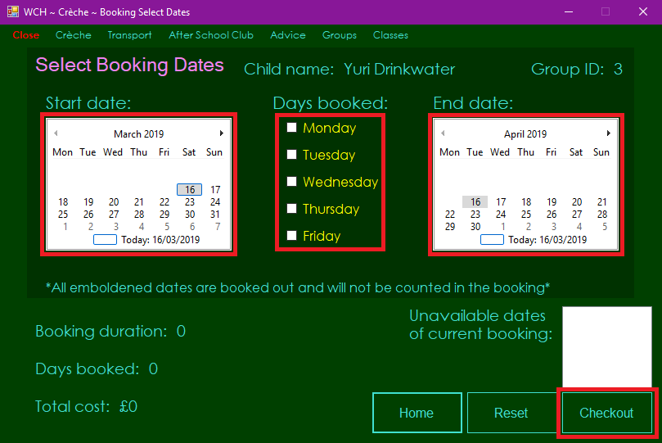

Note:

* Booking duration, number of days booked and booking cost details will change dynamically as the user changes start date, end date or days booked (see below)

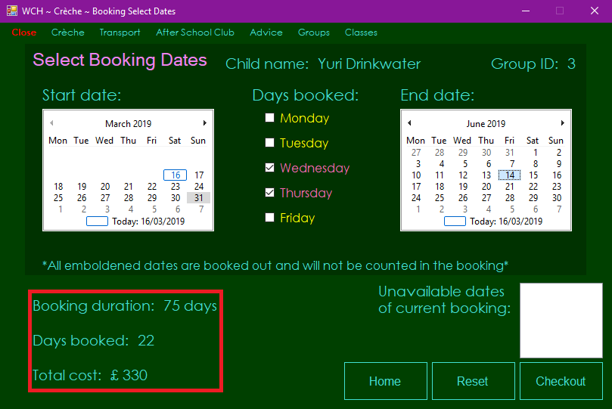

* The minimum duration for a booking is one month, so the user cannot select an end date that is less than one month after the selected start date
* The maximum number of bookings that can take place each day is: six for group one, ten for group two and nine for group three
  + Booked out dates that overlap with the current booking will not be counted in the booking; total cost and number of days booked will not take record of any booked out dates
  + All booked out dates will be emboldened on both calendars; if any of these overlap with the current booking, they will be listed in the ‘Unavailable dates of current booking’ text box and the user will be informed of how many booked out dates overlap with the current booking beside the number of days booked (see below)

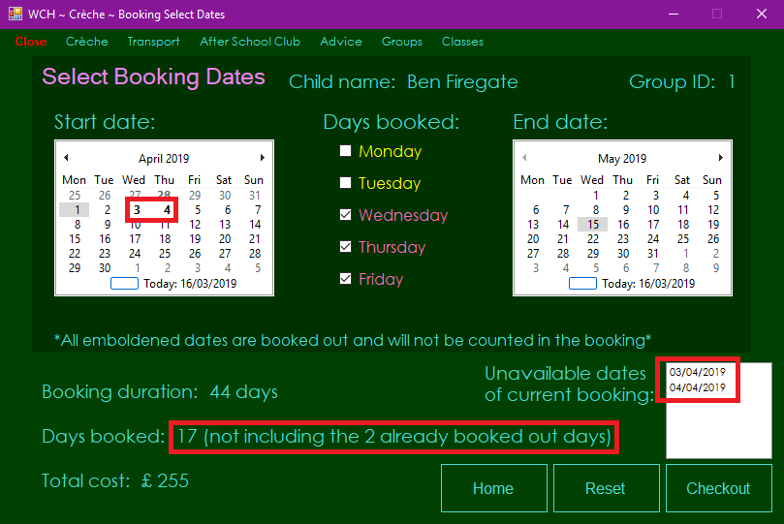

* If the booking start date is between three and six months after the current date, a 3% discount will be applied, if it is over six months after the current date, a 5% discount will be applied (see below)

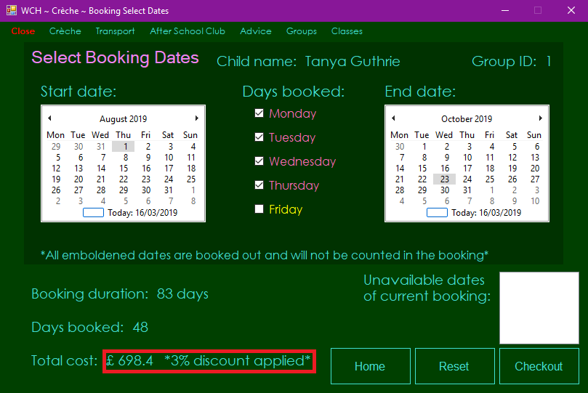

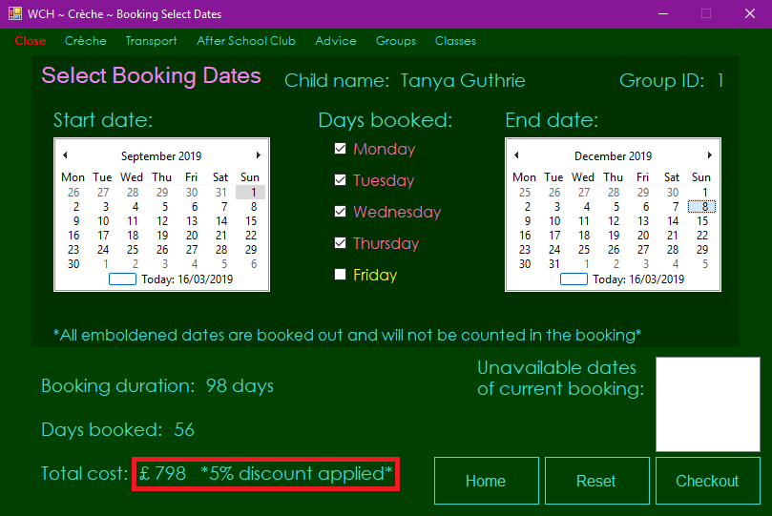

### Parents

1. Click ‘Parent’ button in ‘Add’ section on Crèche Menu Form

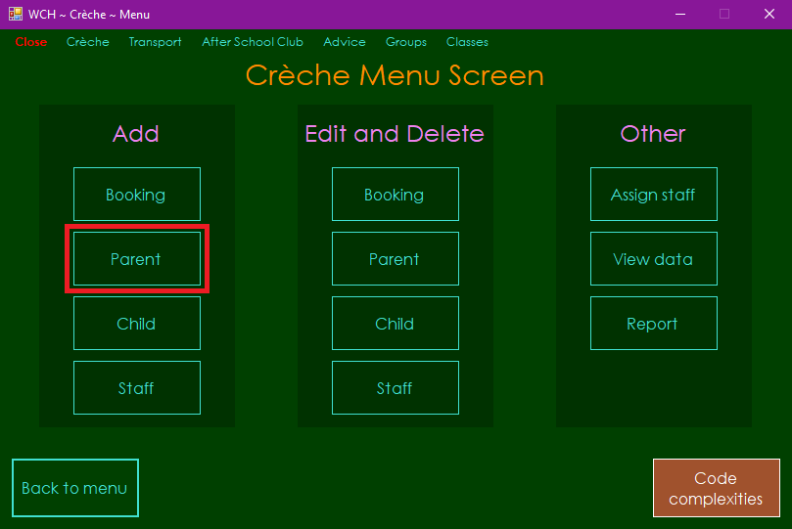

2. Fill parent details into text boxes

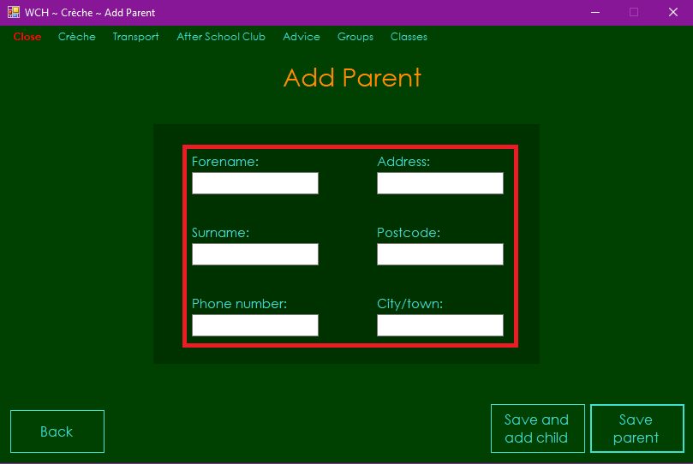

3a. *Follow if you wish to create a new parent and create a new child* – Click ‘Save and add child’ button then click ‘Ok’ on message box that appears

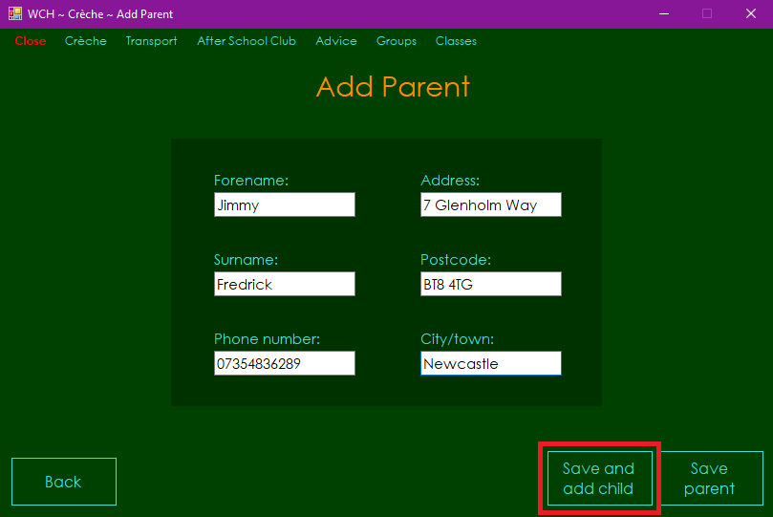

3b. *Follow if you wish to create a new parent without creating a new child* – Click ‘Save parent’ button then click ‘Ok’ on message box that appears

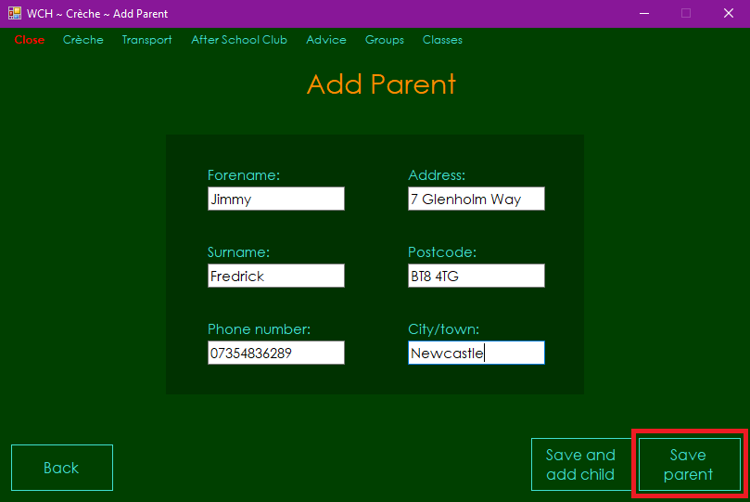

### Children

1. Click ‘Child’ button in ‘Add’ section on Crèche Menu Form

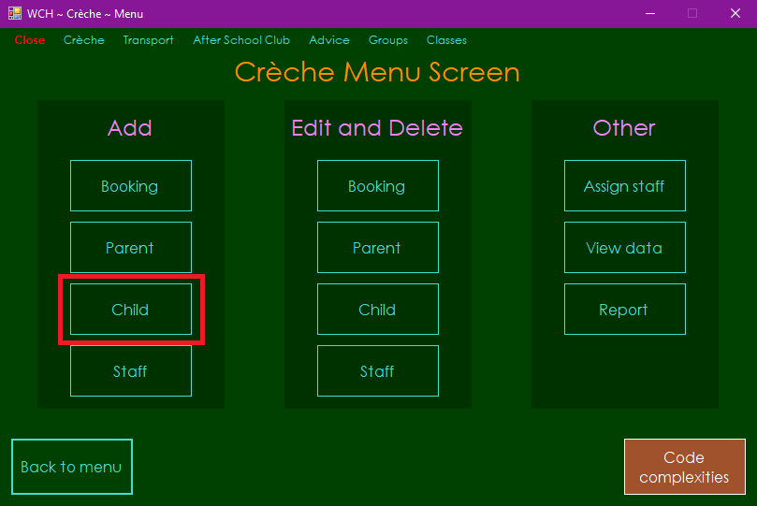

2. Input child forename and surname into text boxes, select child date of birth from calendar, select child’s parent from parent name list box (you can also search for a parent by typing their name into the text box) then click ‘Save child’

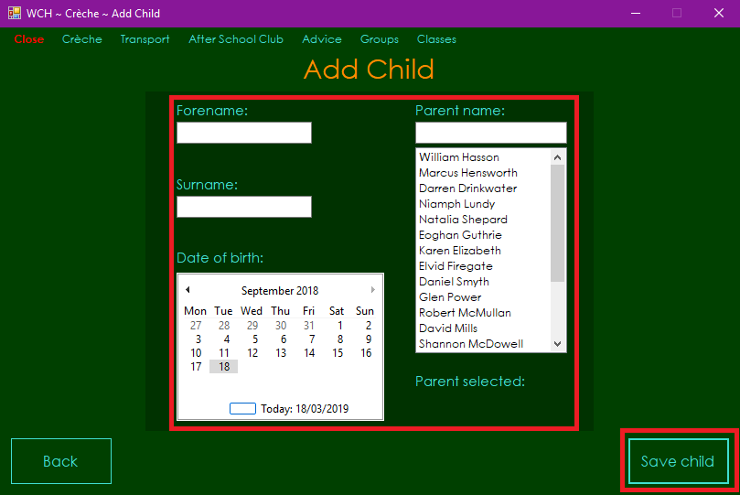

## **Editing and Deleting**

### Bookings

1. Click ‘Booking’ button in ‘Edit and Delete’ section on Crèche Menu Form

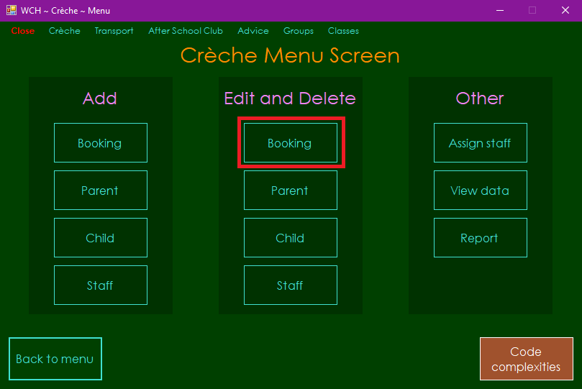

2. Select the child of the booking you wish to edit or delete from child name list box (you can also search for a child by typing their name into the text box) then select the booking you wish to edit or delete in the combo box below

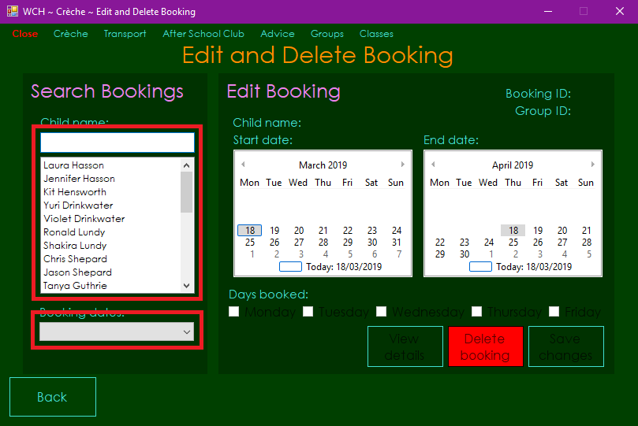

Note:

* If a booking that has a start date of the current date or earlier is selected, the user will be able to delete that booking and view its details, but not edit it.

3a. *Follow if you wish to delete the selected booking* – Click ‘Delete booking’ button then click ‘Yes’ on message box that appears

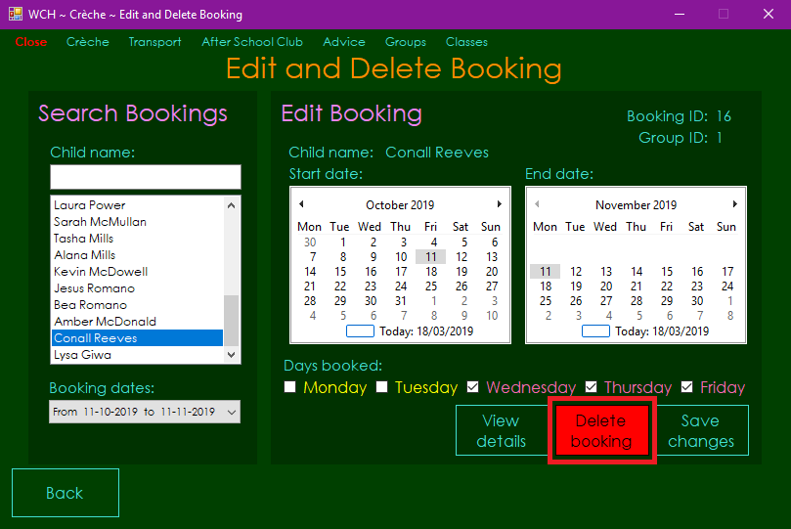

Note:

* You may also view the booking details by clicking ‘View details’ button

3b. *Follow if you wish to edit the selected booking* – Alter the details you wish to change on the calendars and/or check boxes, click ‘Save changes’ button then click ‘Ok’ on message box that appears

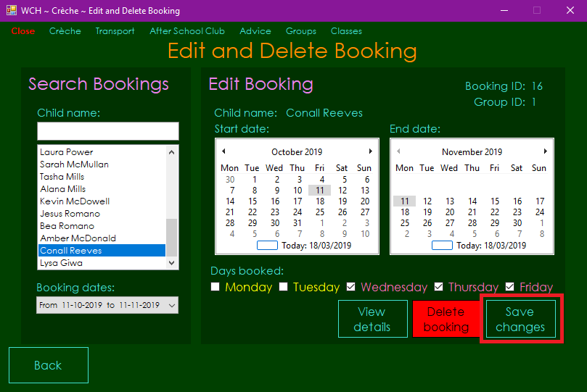

Note:

* You may also view the booking details by clicking ‘View details’ button

### Parents

1. Click ‘Parent’ button in ‘Edit and Delete’ section on Crèche Menu Form

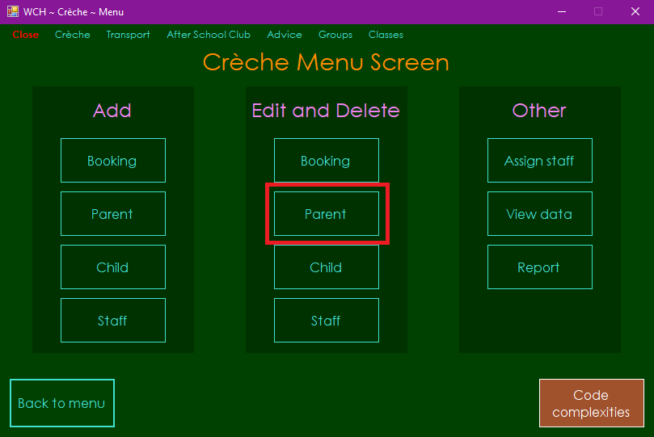

2. Select the parent you wish to edit or delete from the list box (you can also search for a parent by typing their name into the text box)

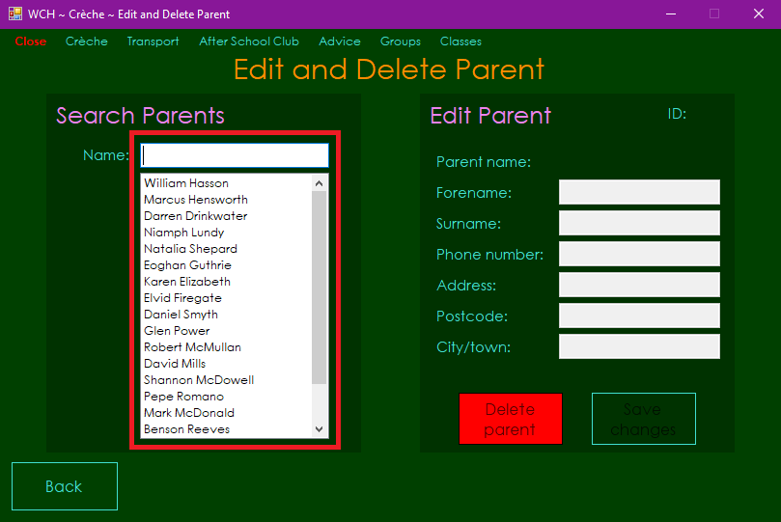

3a. *Follow if you wish to delete the selected parent* – Click ‘Delete parent’ button then click ‘Yes’ on message box that appears

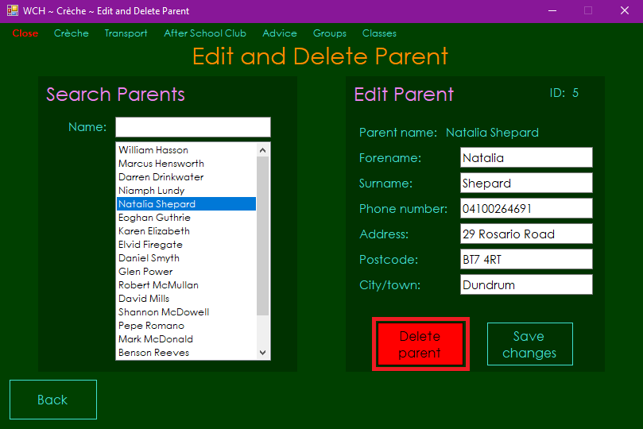

Note:

* All children of the deleted parent will also be deleted
* All future bookings of the deleted parents’ children will be deleted (past bookings are kept so that records can be stored)

3b. *Follow if you wish to edit the selected parent* - Alter the details you wish to change in the text boxes, click ‘Save changes’ button then click ‘Ok’ on message box that appears

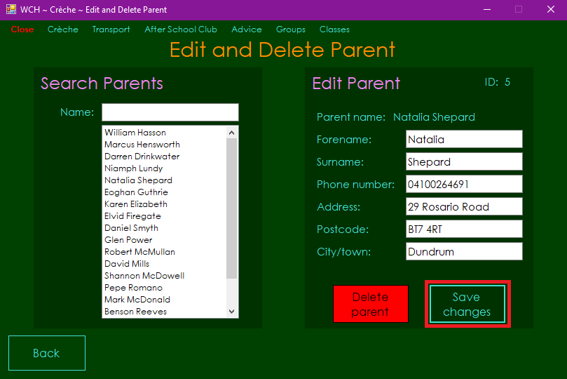

### Children

1. Click ‘Child’ button in ‘Edit and Delete’ section on Crèche Menu Form

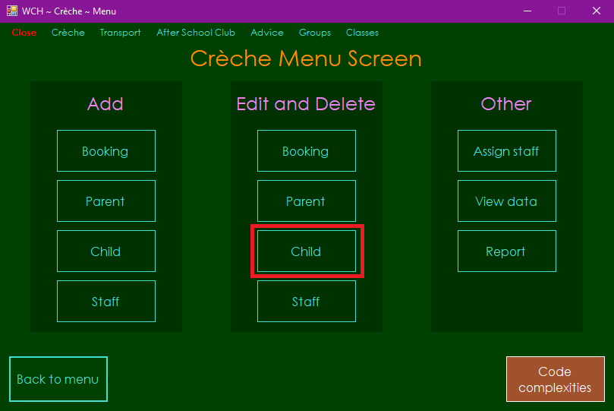

2. Select the child you wish to edit or delete from the list box (you can also search for a child by typing their name into the text box)

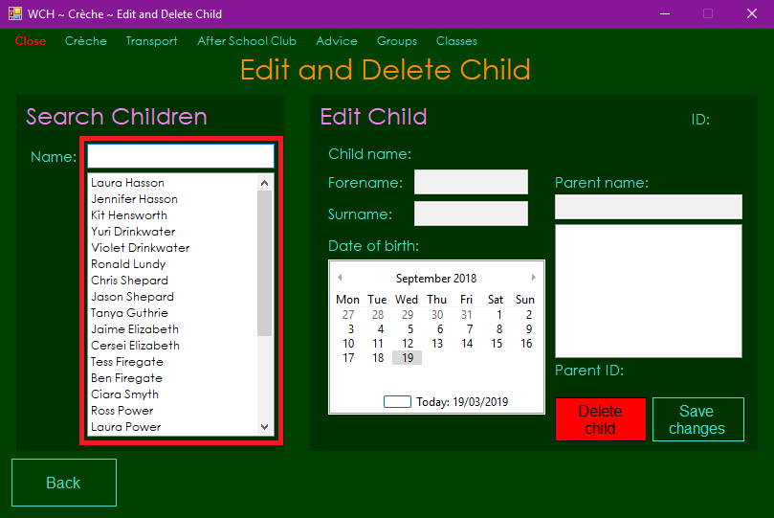

3a. *Follow if you wish to delete the selected child* – Click ‘Delete child button then click ‘Yes’ on message box that appears

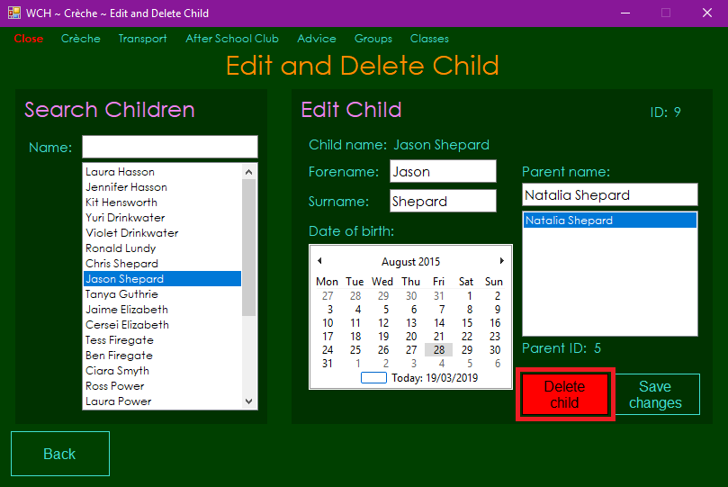

Note:

* All future bookings of the deleted child will be deleted (past bookings are kept so that records can be stored)

3b. *Follow if you wish to edit the selected child* - Alter the details you wish to change in the text boxes, calendar and/or list box, click ‘Save changes’ button then click ‘Ok’ on message box that appears

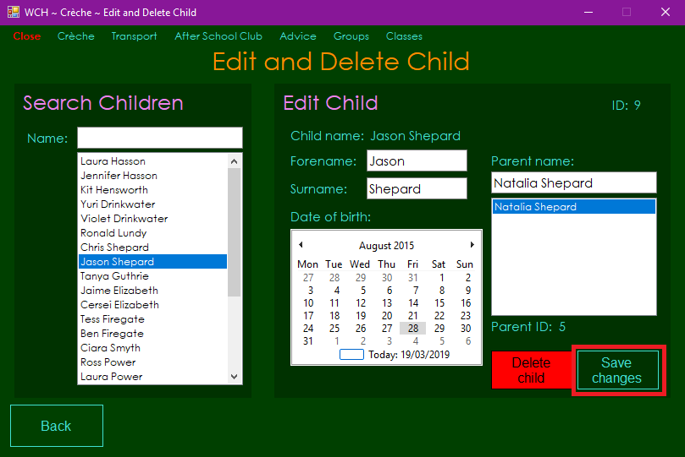

## **Assigning Staff**

1. Click ‘Assign staff’ button in ‘Other’ section on Crèche Menu Form

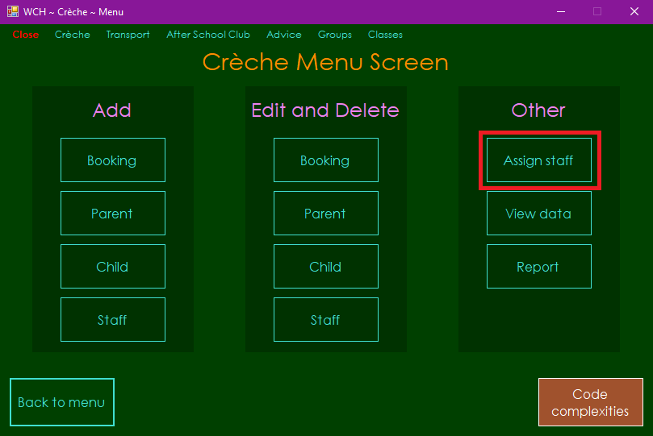

2. Select your desired date on the calendar

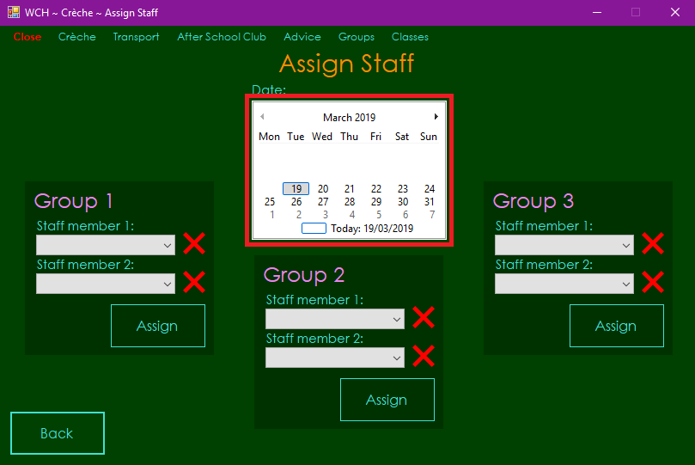

Note:

* Staff cannot be assigned on weekends as the crèche only runs Monday to Friday

3. Select the staff members you wish to assign in the combo boxes of the group(s) you wish to assign them to

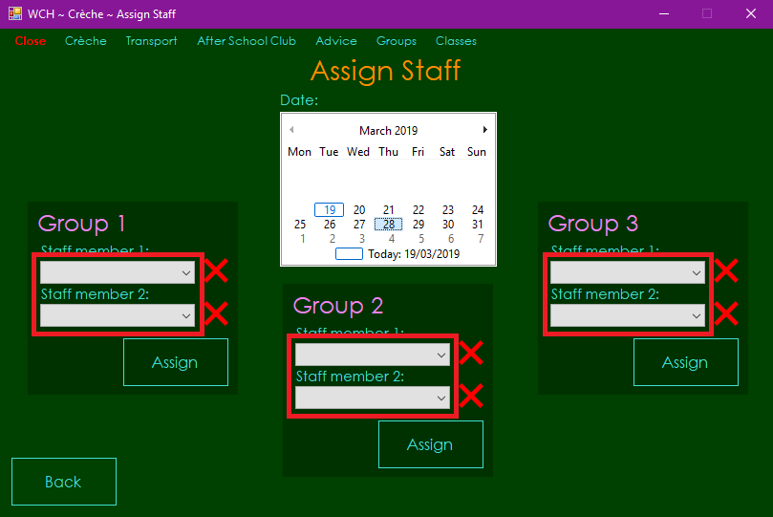

Note:

* Once a staff member has been selected in one combo box, they cannot be selected in any of the other combo boxes unless the user removes them from the combo box my clicking the red X beside it

4. Click ‘Assign’ button in the group(s) to which you wish to assign staff

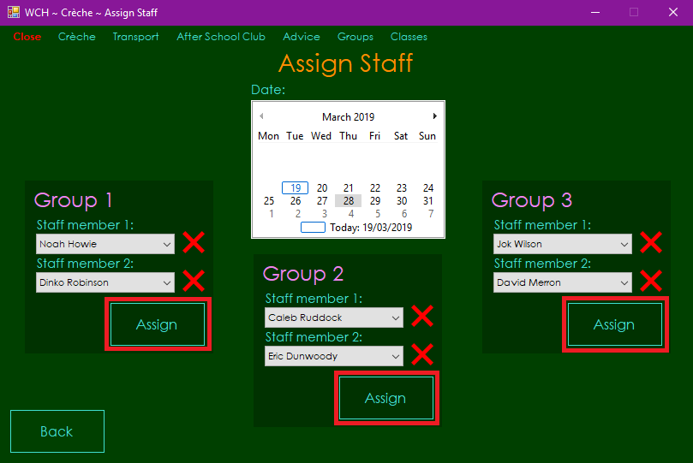

Note:

* Staff members must be assigned to each group two at a time

## **Viewing Data**

1. Click ‘View data’ button in ‘Other’ section on Crèche Menu Form

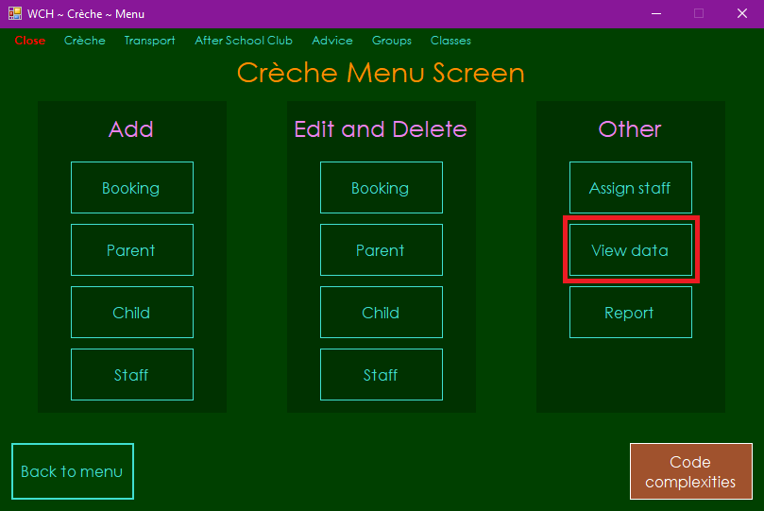

2. Select the radio button for the table with the data that you wish to view

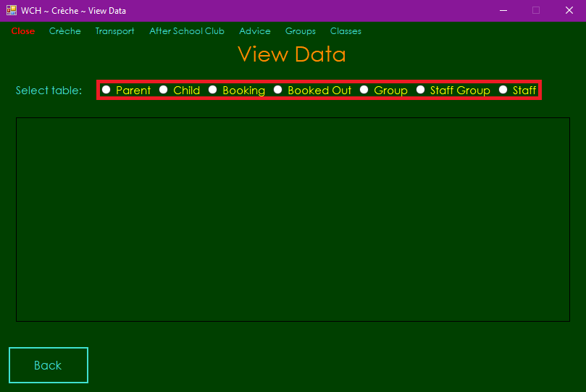

## **Viewing Report**

1. Click ‘Report’ button in ‘Other’ section on Crèche Menu Form

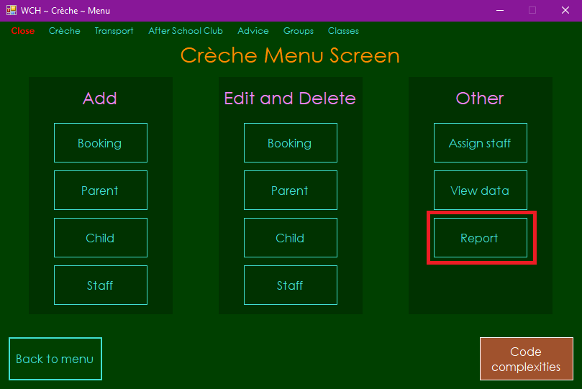

2. Select the earliest and latest start date you wish to view a report of from the date pickers, then click the ‘Confirm’ button below

